Bode plots and frequency response in PSIM

**Date: 05.11.2020**

**ELCE 200**

Student name: Sanzhar Yergaliyev

Student id: 201894694

E-mail: [sanzhar.yergaliyev@nu.edu.kz](mailto:sanzhar.yergaliyev@nu.edu.kz)

**PSIM tool that shows the frequency response: AC sweep**

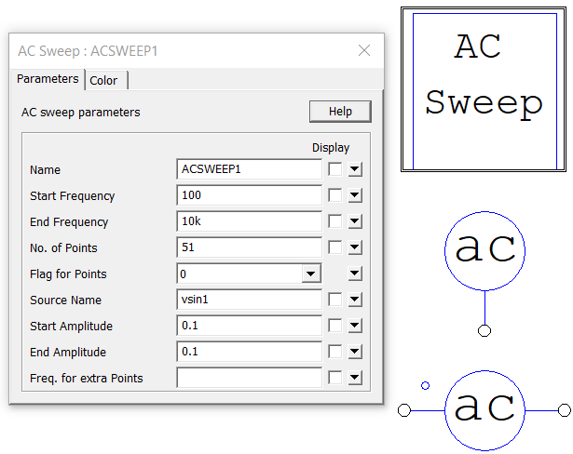

You can find AC sweep through a library search in PSIM.

How to configure:

1. Start and end frequency is basically your range.
2. Number of points is the resolution of your plots.
3. Flag for points: 0 – for log scale, 1 – for linear scale.
4. Put the name of the sinusoidal voltage source.
5. The rest can be set default.

How to probe:

You can treat AC probe as a voltmeter and use it similarly. Put you AC sweep probe (either one called loop, or the one terminal probe with proper ground) between the nodes of the output of the filter.

More you will see in the actual simulation.

**Verification**

To verify the results, we get from PSIM, we plot the transfer functions in MATLAB to compare them.

The command we use to plot Bode diagram is *bode(nom,denom)* from the Control System Toolbox (you should download it, it is included in the Academic version). The instructions can be find in MATLAB documentation or on the lecture slides.

Here, is the MATLAB code we will use in this document (Live script):



**Simulation**

Here are the circuits for filters we considered in lectures. Every filter is followed by the plots from MATLAB and a PSIM file that contains the circuit. You can directly open it in PSIM by clicking on it.

If you click on the file, you will need to specify the PSIM executable file to open it.

*PSIM executable file is in the “Powersim” directory.

*Possible location is C:\Powersim\PSIM_2020a_Demo\PSIM.exe

**Circuits**

Values that we will use. (That PSIM assigns by default)

C = 10^(-6); %Farad

L = 10^(-3); %Henry

R = 10; %Ohm

**First order Low pass FIlter**

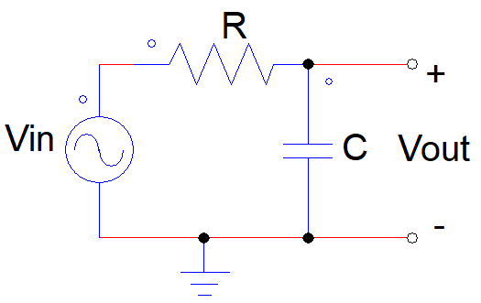

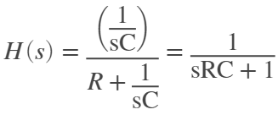

nom = [1];

denom = [R*C 1];

bode(nom,denom),grid %to use this function download Control System ToolBox

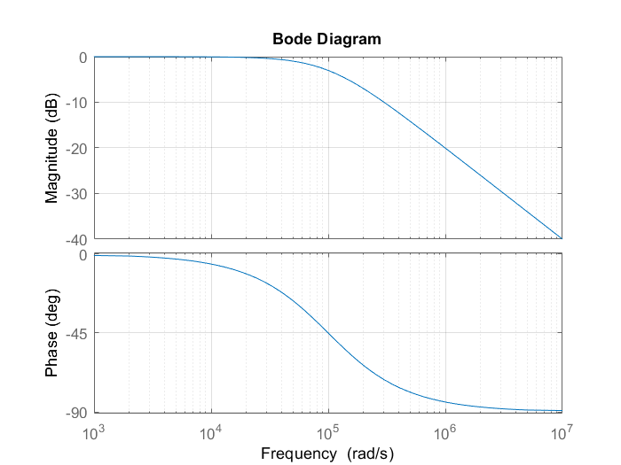

fb = 1/(2*pi*R*C)

fb = 1.5915e+04

wb = 1/(R*C)

wb = 1.0000e+05

**PSIM Simulation:**



**First order High pass FIlter**

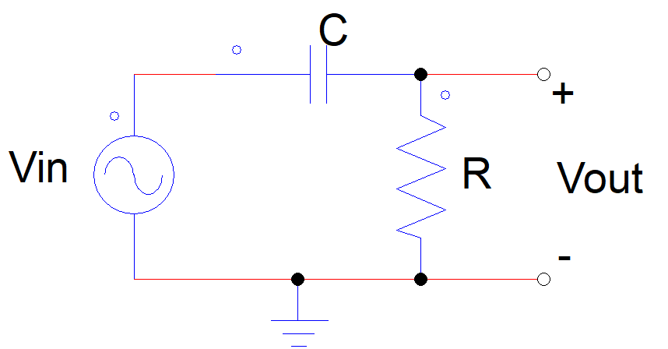

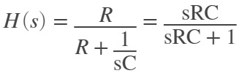

nom = [R*C 0];

denom = [R*C 1];

bode(nom,denom),grid

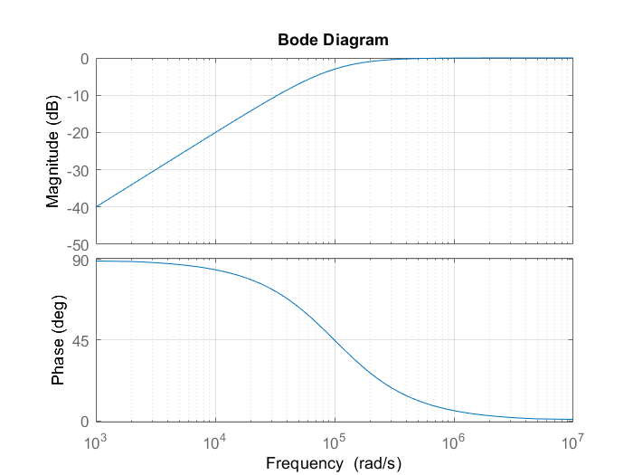

Has the same break frequency.

**PSIM Simulation:**



**Second order FIlters and Butterworth function**

Let's also see Butterworth function, when quality factor 

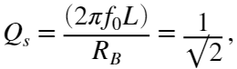  where 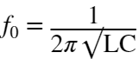

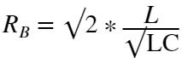

f0 = 1/(2*pi*sqrt(L*C))

f0 = 5.0329e+03

Qs = 2*pi*f0*L/R

Qs = 3.1623

RB = sqrt(2)*L/sqrt(L*C) %Ohm

RB = 44.7214

**Second order Low pass FIlter**

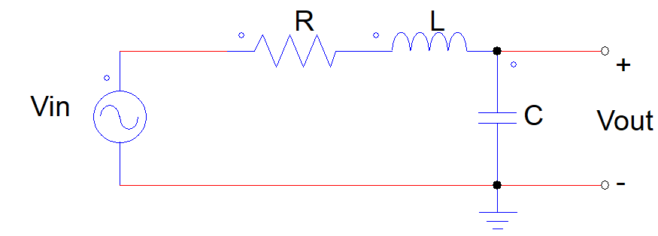

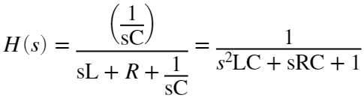

nom = 1;

denom = [L*C R*C 1];

bode(nom,denom),grid

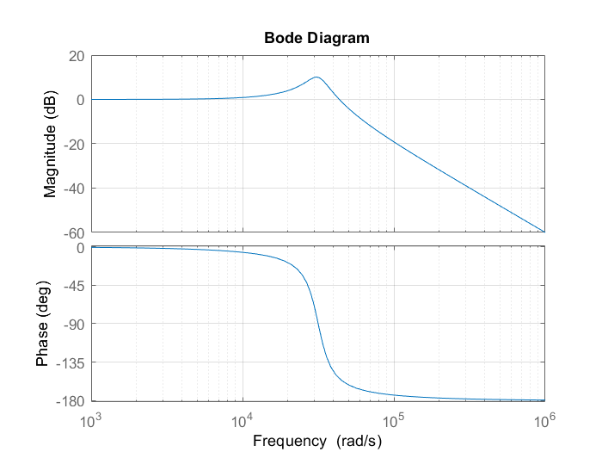

nom = 1;

denom = [L*C RB*C 1];

bode(nom,denom),grid

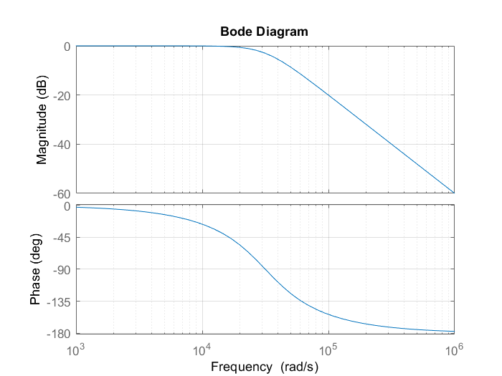

PSIM Simulation:





**Second order High pass FIlter**

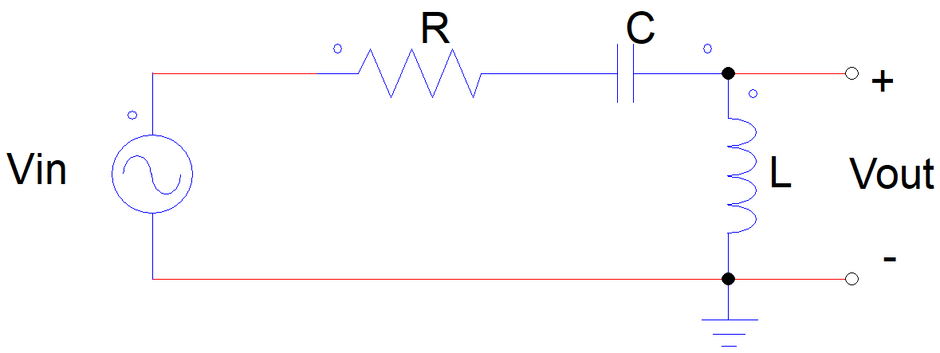

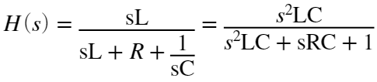

nom = [L*C 0 0]; %for the defult R

denom = [L*C R*C 1];

bode(nom,denom),grid

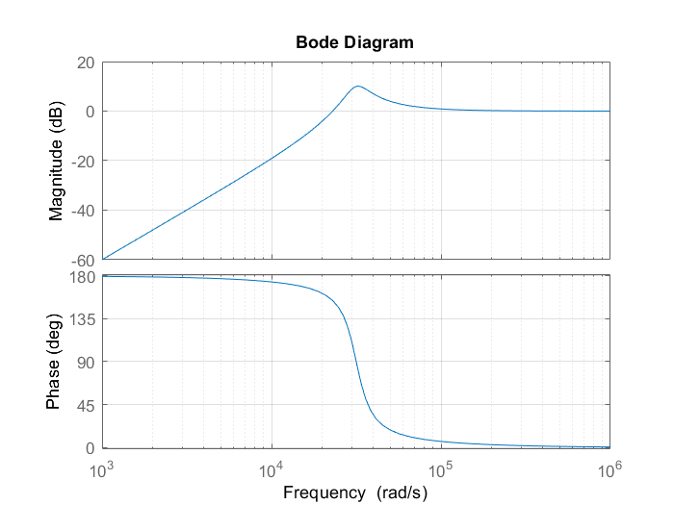

nom = [L*C 0 0]; %for the Butterworth function

denom = [L*C RB*C 1];

bode(nom,denom),grid

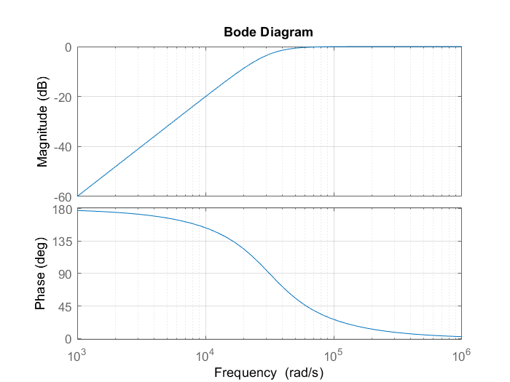

PSIM simulation:





**Second order Band pass FIlter**

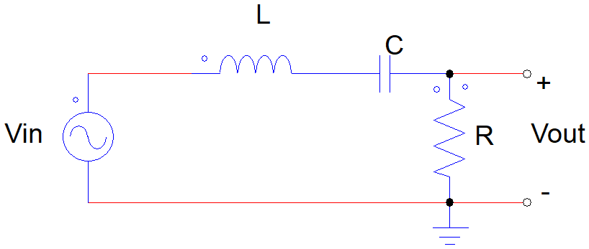

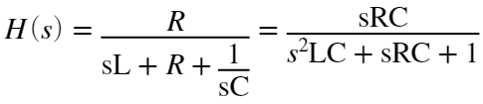

nom = [0 R*C 0]; %for the defult R

denom = [L*C R*C 1];

bode(nom,denom),grid

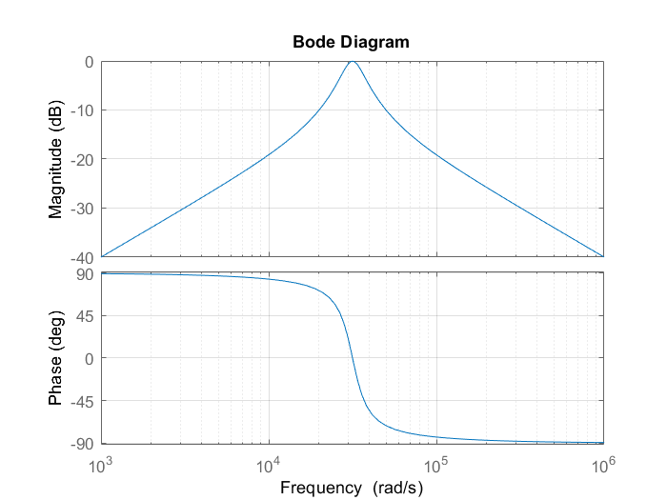

PSIM simulation:



**Second order Band-reject FIlter**

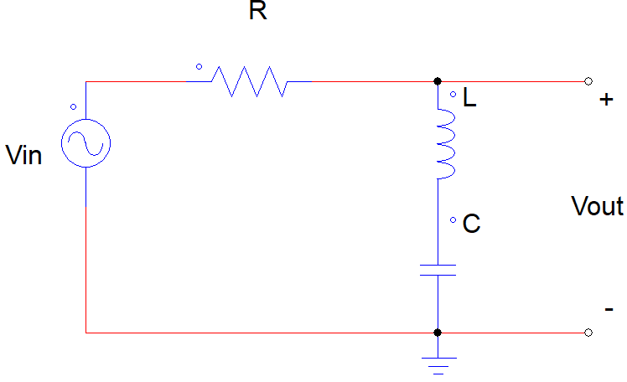

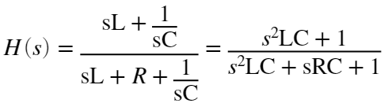

nom = [L*C 0 1];

denom = [L*C R*C 1];

bode(nom,denom),grid

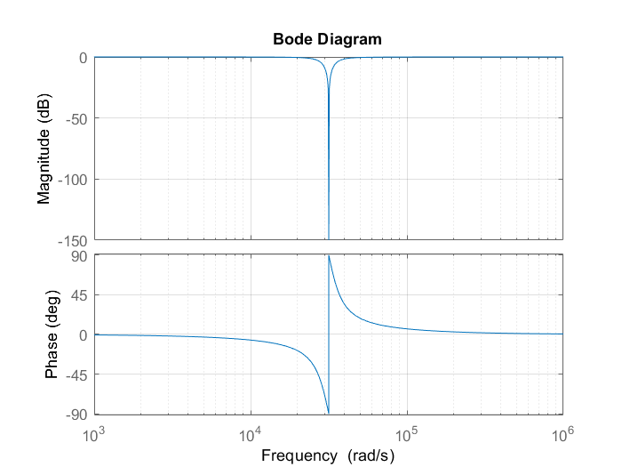

PSIM simulation:

